1. Right click on any table in CDSDATA.mdb database, select Import -> Text File.

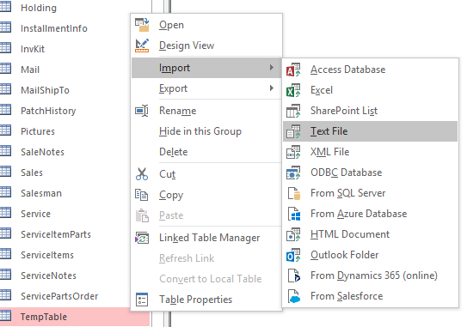

1. Click the browse button and select the “TempTable.txt” file.

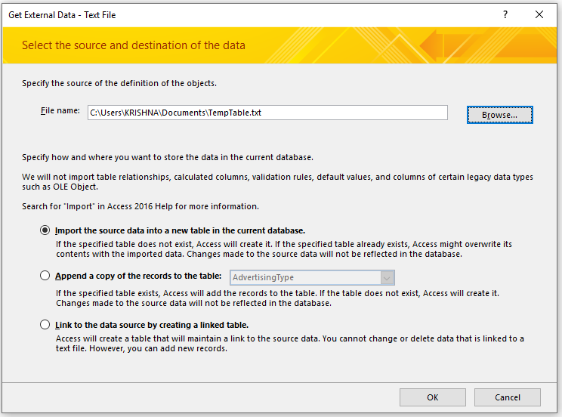

1. Click “OK” button.
2. Click “Next” button without any changes here.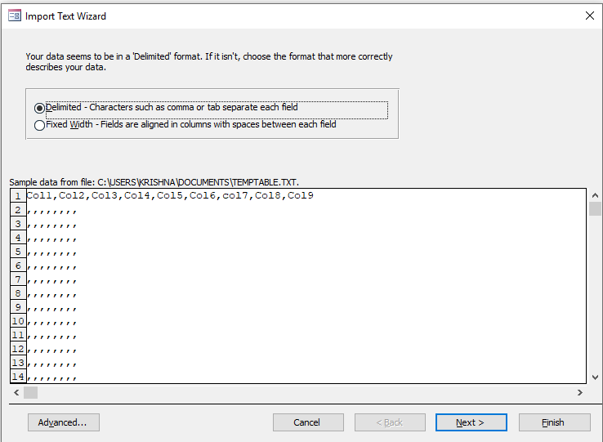
3. Select “First Row Contains Field Name” checkbox and Text Qualifier as “{none}”.

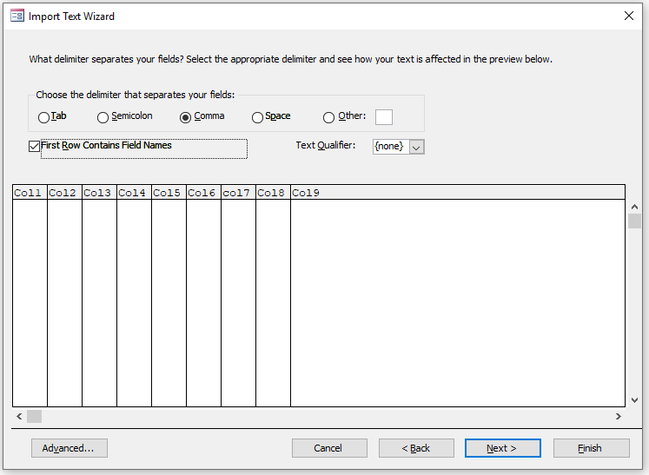

1. Click “Next” button.

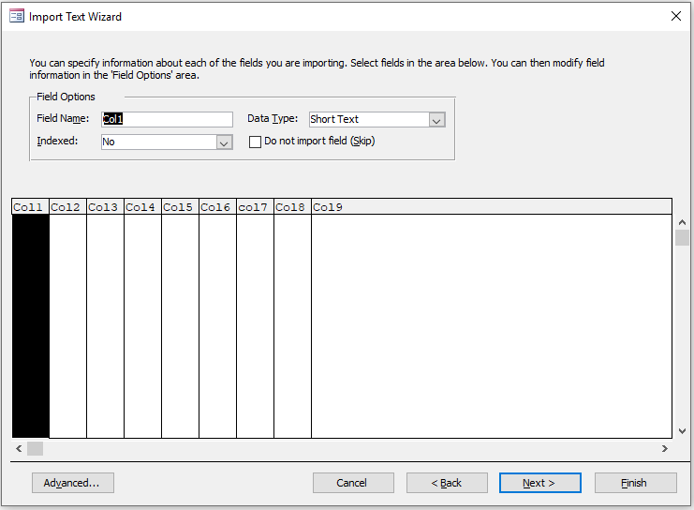

1. Choose “No Primary Key” option and click on “Next” button.

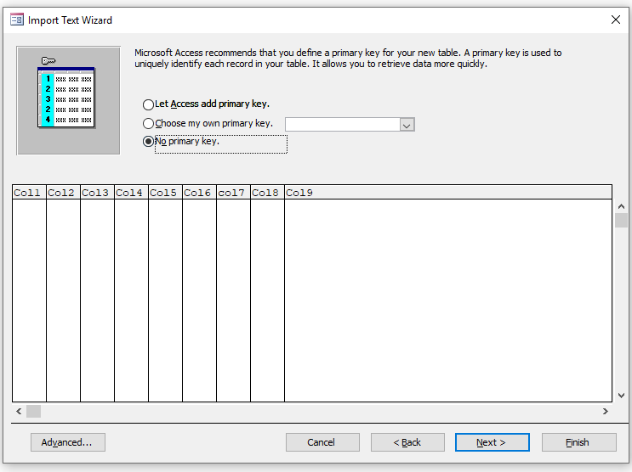

1. Leave the table name as “TempTable” and click on “Finish” button.

